验证码
- 安装
pip install django-simple-captcha
- 配置
2.1 setting.py
因为captcha本身就是app,所以要加入到INSTALLED_APPS
INSTALLED_APPS = [
'django.contrib.admin',
'django.contrib.auth',
'django.contrib.contenttypes',
'django.contrib.sessions',
'django.contrib.messages',
'django.contrib.staticfiles',
'hello.apps.HelloConfig',
'captcha',
]
2.2 urls.py
from django.urls import path,include
url(r'^captcha',include('captcha.urls')),

- 数据库同步
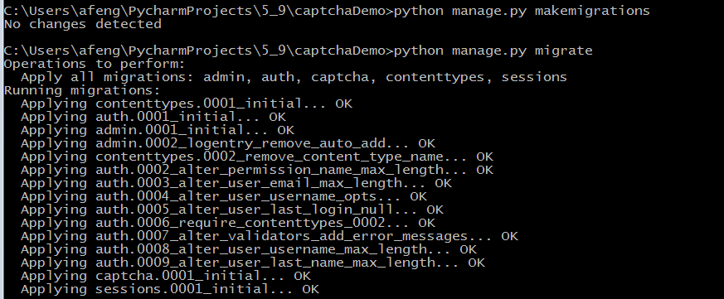
- 定义一个form
from captcha.fields import CaptchaField
from django import forms
class RegisterForm(forms.Form):
email = forms.EmailField(required=True)
password = forms.CharField(required=True, min_length=5)
captcha = CaptchaField(error_messages={"invalid": u"验证码错误"})

- 定义一个views.py
from django.views.generic.base import View
class RegisterView(View):
def get(self,request):
register_form = RegisterForm()
return render(request, "index.html", {"register_form": register_form})
def post(self,request):
register_form = RegisterForm(request.POST)
if register_form.is_valid():
print(register_form.cleaned_data['email'])
print(register_form.cleaned_data['password'])
print(register_form.cleaned_data['captcha'])
return render(request,"main.html")
else:
return render(request, "index.html", {"register_form": register_form})

- 静态页面
<!DOCTYPE html>
<html lang="en">
<head>
<meta charset="UTF-8">
<title>Title</title>
</head>
<body>
<div>
<label>验证码</label>
<form action="reg" method="post">
{% csrf_token %}
{{ register_form.as_p}}
<input type="submit" value="登录"/>
</form>
</div>
</body>
</html>

七、帮助文档：

http://django-simple-captcha.readthedocs.io/en/latest/usage.html#installation

